Sexual reproduction, meiosis and gamete formation
Two parents are needed in sexual reproduction. In sexual reproduction the male sex cell (sperm) fertilizes the female sex cell (ovum) in order to create a zygote – a fertilised ovum and the very first cell of a new organism. This process is known as fertilisation.
Sperm and Ovum are created in a different way to all other cells in your body. Normally, your body uses a process called mitosis to create exact copies of cells. The new cells created by mitosis are able to replace existing cells or add to the existing cells in the body. Thus, mitosis produces cells which can replace dying cells or help us grow.
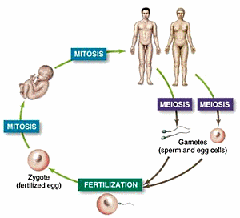
The sex cells are different. The sperm and ovum are called gametes (it’s easier to use than “sperm and ovum”). Sex cells are produced in a process called meiosis (my-o-sis). Meiosis happens only in the reproductive organs (the testes and ovaries), and meiosis only occurs to make the gametes. Meiosis uses a normal cell (like mitosis), but the new cell made(the sperm or ovum) have only half the full number of chromosomes.
Thus, in humans this means the sperm and the ovum contain only 23 chromosomes rather than the normal number of 46. Gametes are sometimes referred to as haploid for this reason. Normal cells, with 46 chromosomes are called diploid. When the male gamete from one individual, and female gamete from a second individual combine, they create a zygote with the full complement of chromosomes – in humans this would be 46 chromosomes. This means the new organism has two sets of chromosomes making up their 46 chromosomes - one set of 23 chromosomes from their mother and one set of 23 from their father. This means that rather than have 46 quite different chromosomes, humans have 23 pairs of chromosomes.
The gametes (sperm and ovum) do not always contain the same 23 chromosomes, so the zygote will have a unique mix of chromosomes. The offspring produced in sexual reproduction are therefore genetically similar to their parents but not identical to either, or necessarily a combination of the parents. This process results in variation within a population because it involves the mixing of genetic information.

